**4. System Analysis**

**4.0 System Analysis**

System Analysis is a Process of collecting data, understand the process involved, identifying problem and recommending feasible suggestion for improving the system functioning.

**4.1 Study of Current System**

We have to build such application which can act as internet free service it means that the you have authorization of to open our site and you can see our new launch events, and detail about events, culture , technical ,sports etc.

**4.2 Feasibility Study**

* The Feasibility analysis is categorized under four different types.

1) Operational Feasibility.

2) Technical Feasibility.

3) Schedule Feasibility.

4) Economical Feasibility.

**1) Operational Feasibility:-**

Basically Operational Feasibility as how application work as execute in market

There are type of people which is focus user of application in arm research. We set focus on smooth operative of are application because some user for technical person with sufficient knowledge of how to operate application and some of done people who not really technical sound so our UI is user friendly and feasible to all.

**2) Technical Feasibility:-**

In process of Application we mention all the process and structure in particular co-or dinar between development, design, and test. We set example in real market and we found are application is fair easy and good to work on it.

**3) Scheduling Feasibility :-**

Here we are create schedule for BIET Activity Zone and our team or project partner follow mention timeline to execute follow application and we have also move for work before actual project deadline or submission date.

**4) Economical Feasibility :-**

There is so many criteria of application success but main boundary of application is cost and time feasibility so Estimation of time & cost feasibility is fruitful to are clients in our

company. We doing this project is IDP so well structured even byour company.

**4.3 Requirement Validation**

* Functional requirement defines internal working of application .The calculations, data manipulation and processor specific functionality for customers.
* “Validation typically involves actual testing and takes alter verifications are complemented”
* Only BIET students can participate in this events.
* Validation refers to the process of using the system in the actual live environment in order to find error .If the Results obtained from the System are proper, the system is valid; else it is no.
* A sour project is to build a dynamic web-site, there are no criteria such as windows authentication but still some security must be provided in essence of making the rights of certain entity to be limited to them. Certain validation criteria that are needed listed below.

**4.4 System Design**

* Build a web based system.
* Information handling of the registered student. I.e. new records can be created, data retrieval, update functionality.
* The functionality of the project is to develop customize software package for reducing the manual problems.
* It should deals with the online Registration as well as cancellation.
* This system never decreases the manpower but helps the development of available manpower and optimizes the manpower by which banquet’s standards and capabilities can be scaled to higher dimension.

**4.4.1 Use Cases, event trace or scenario**

Use case diagrams hows the typical in traction of user to system. Above figure Shows the how user interact with system.

He inserts or delete or update or view the records from the system. If he /she want to enter in the system he has to pass from login portion of system for checking of authorization of person.

**Function Use Case Diagram.**

**Various notations used in the use case diagrams are:**

* + **Use case**
* **Actors**
* **Association Relationship**

**Usecase Diagram for Admin:-**

**Furniture**

**ADMIN**

**Usecase Diagram for Client** **:-**

**CLIENT**

**Furniture**

**4.4.2 Data Modeling and E-R Diagram**:

**E-R Diagrams:-**

m

m

m

1

m

m

1

stock

User_reg

m

Delar_detail

User order

User

ord

m

Subcat

Category

Pro.

Give ord.

sub

m

Product

m

Furniture

Branch_detail

City

m

**4.4.3 Data Dictionary**

* **Admin_reg:**

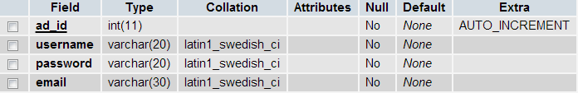

**Description:** This Table stores all the required Information of the admin who have created username and password.

* **Branch _detail:**

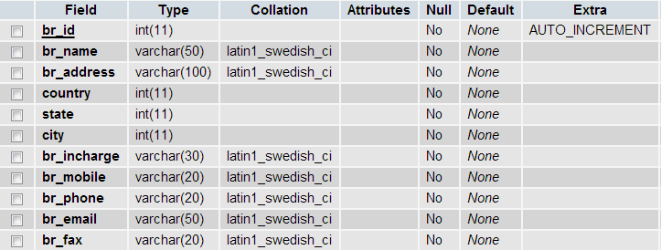

**Description:** This table stores the add branch detail in user account.

* **Category:**



**Description:** This table gives the information of category in user.

* **City:**

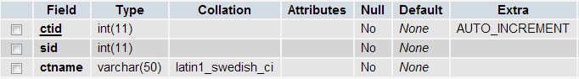

**Description:** This table stores the city which the admin inputs.

* **Country:**

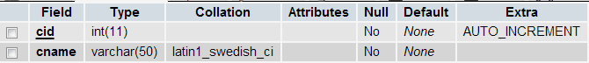

**Description:** This table stores the country releated information in new user.

* **Csr:**



**Description:** This table display the any cirtificates for the user viewing.

* **Dealer_detail:**

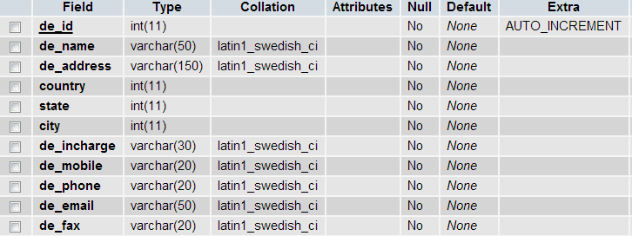

**Description:** This table stores the dealer information in it.

* **Product:**

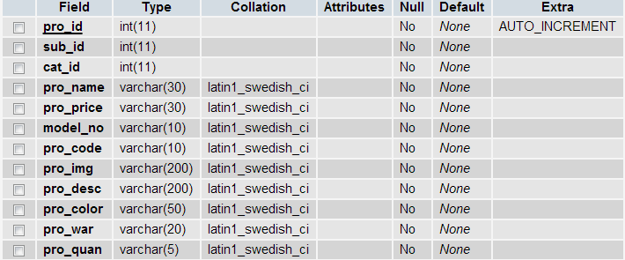

**Description:** This table display the products for the user viewing.

* **State:**

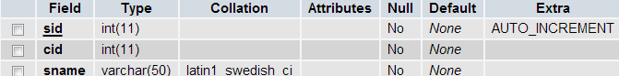

**Description:** This table display the information of state for the user viewing.

* **Subcat:**

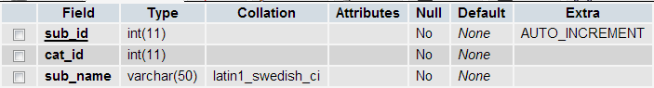

**Description:** This table display the sub categories for the user viewing.

* **User_feedback:**

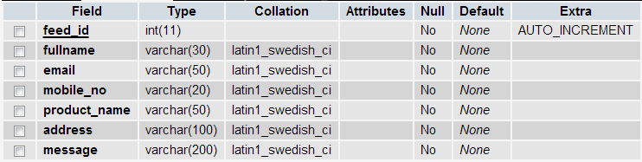

**Description:** This table shows the articles of feedback the user viewing.

* **User_order:**

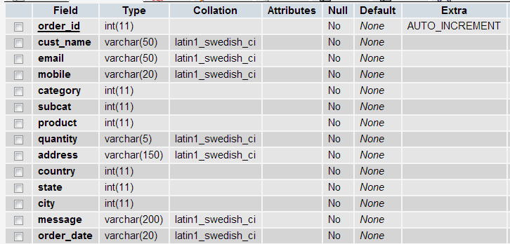

**Description:** This table display the order of the user viewing.

* **User_reg:**

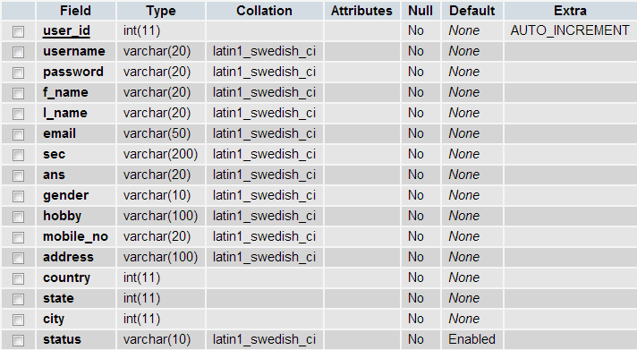

**Description:** This table display the user register for the user viewing.

**4.4.4 Data Flow Diagram (Context Level)**

Data Flow Diagram is a graphical a id for defining systems inputs, outputs and processes. It represents flow of data through the system.

The DFDs are used in modern methods of System Analysis. They are simple to the extent that the types of symbols and rules are very few. DFDs serve two purposes:

(1)Provide a graphic tool, which can be used by the analysts to explain his understanding of the system to the user

(2) They can be readily converted into a structured chart which can be used in design.

**1stLevel DFD:-**

* **Data Flow Diagram(Notation) :-**

Process that transforms data flow.

Source or Destination of data

Data Flow

Data Store

**DIAGRAM::**

**LEVEL 0 :-**

Response

Order

login

Verify

Detail check

Response

Response

Order

**Client**

Login

**Manage order**

Response query

Response

Response

**Product Manage**

Response

**Admin**

Verify

Ask for product

Response

**LEVEL 1 :-**

User_reg

product

User order

User_reg

Client

User order